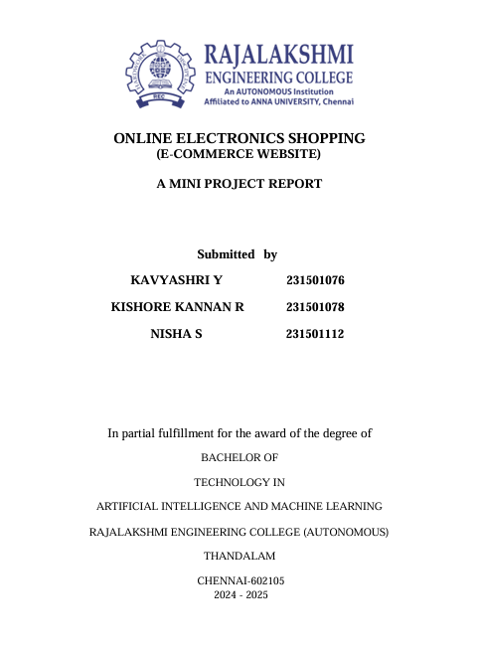

RAILWAY RESERVATION PROJECT

**DEEPIKA M (231801028)**

**DATA SCIENCE**

**TABLE OF CONTENTS**

**1. INTRODUCTION**

1.1 INTRODUCTION

1.2 OBJECTIVES

1.3 MODULES

**2. SURVEY OF TECHNOLOGIES**

2.1 SOFTWARE DESCRIPTION

2.2 LANGUAGES

**3. REQUIREMENTS AND ANALYSIS**

3.1 REQUIREMENT SPECIFICATION

3.2 HARDWARE AND SOFTWARE REQUIREMENTS

3.3 DATA DICTIONARY

**4.PROGRAM CODE**

**5. RESULTS AND DISCUSSIONS**

**6. CONCLUSION**

**7. REFERENCES**

**ABSTRACT**

The **Railway Reservation System** is a software solution developed to streamline the process of booking train tickets. This system allows users to enter details such as their name, train number, seat number, and date of travel to book tickets efficiently. Developed using Java for backend processing, Swing for the graphical user interface, and MySQL for database management, the system ensures reliable and secure data handling. PhpMyAdmin, managed through XAMPP, facilitates database administration. This project leverages a modular architecture, dividing the application into distinct components, each with specific responsibilities. By automating the booking process, the system aims to minimize manual errors, enhance efficiency, and improve the overall user experience.

**INTRODUCTION**

**1.1 INTRODUCTION**

The railway network is one of the most critical infrastructures for mass transportation, offering a cost-effective and efficient means of travel. With millions of passengers relying on trains daily, an efficient and user-friendly ticket booking system becomes essential. Traditional manual booking systems often suffer from inefficiencies, inaccuracies, and long processing times. To address these challenges, the **Railway Reservation System** was designed and implemented.

This project provides users with an intuitive graphical user interface for booking train tickets by entering the required details. Built using Java programming language and Swing for GUI development, the system seamlessly interacts with a MySQL database for storing and retrieving data. PhpMyAdmin, accessed via XAMPP, serves as the database management tool, ensuring ease of administration and debugging.

Key features of the system include:

* A database to store train schedules, passenger information, and booking records.
* An interactive UI for entering passenger details.
* A modular design for ease of maintenance and scalability.

This system addresses the shortcomings of traditional booking methods and lays the groundwork for future enhancements like payment gateways, seat availability checks, and real-time train tracking.

**1.2 OBJECTIVES**

The Railway Reservation System has been developed with the following objectives:

1. Automation of Ticket Booking  
   To replace the manual ticket booking process with a computerized system that provides faster, more accurate, and efficient booking services for passengers.
2. Real-Time Availability  
   To enable users to check the real-time availability of trains, seats, and schedules for a hassle-free reservation experience.
3. Data Integrity and Security  
   To ensure the secure handling of user data, booking records, and train schedules by implementing robust database management practices using MySQL.
4. Ease of Use  
   To design a user-friendly interface that simplifies the reservation process for users, requiring minimal technical expertise to navigate and operate.
5. Error Reduction  
   To minimize human errors in the reservation process by automating critical operations such as ticket confirmation, cancellation, and data entry.
6. Centralized Data Management  
   To create a centralized repository for storing and managing data related to users, trains, and reservations, facilitating easy retrieval and updates.
7. Scalability and Flexibility  
   To develop a system that is scalable and flexible, allowing future enhancements, such as online payments, mobile app integration, or multi-user access.
8. Efficient Administration  
   To simplify administrative tasks such as updating train schedules, monitoring reservations, and generating reports, thereby improving overall system management.
9. Practical Application  
   To provide a real-world demonstration of integrating programming, database management, and server tools for developing a robust software application.

**1.3 MODULES**

The **Railway Reservation System** is designed with a modular approach to ensure clear separation of functionalities and maintainability. Below are the key modules and their descriptions:

**1. Database Module**

* **Purpose**: This module is responsible for managing all interactions with the database. It establishes secure connections and executes queries for data storage and retrieval.
* **Key Features**:
  + Establishing and closing database connections.
  + Managing train schedules, passenger information, and booking data.
  + Ensuring data integrity and security.

**2. Train Management Module**

* **Purpose**: This module handles all operations related to train information. It retrieves train schedules and other relevant details from the database for users to make informed choices.
* **Key Features**:
  + Fetching and displaying train details such as name, departure time, arrival time, source, and destination.
  + Providing options for available trains based on user inputs.

**3. Booking Module**

* **Purpose**: This module captures user inputs and processes ticket bookings. It validates the entered details and stores the booking information in the database.
* **Key Features**:
  + Collecting passenger details like name, train number, seat number, and date of travel.
  + Storing the booking information in the database for record-keeping.
  + Ensuring no duplication or conflicts in seat allocation.

**4. User Interface (UI) Module**

* **Purpose**: This module provides an interactive platform for users to interact with the system. It simplifies the booking process through a graphical interface.
* **Key Features**:
  + Input fields for passenger details, train number, seat number, and travel date.
  + Buttons to submit booking details and display confirmation.
  + Error messages for invalid inputs or missing information.

**SURWAY OF TECHNOLOGY**

**2.1Software description**

The Railway Reservation System is a Java-based software designed to automate the process of booking train tickets. It provides a user-friendly interface for entering booking details such as passenger name, train number, seat number, and travel date, while securely managing data in a MySQL database. The system ensures efficiency, accuracy, and convenience for both users and administrators.

1. Technologies Used

* Java: For backend development and business logic.
* Swing: For creating an intuitive graphical user interface.
* MySQL: For secure storage of train schedules, passenger details, and bookings.
* PhpMyAdmin (via XAMPP): For database management and administration.

2. Functionalities

* Ticket Booking: Users can book tickets with essential details.
* Train Management: Displays train schedules and related information.
* Data Validation: Ensures accurate and conflict-free bookings.
* Database Storage: Safely records booking information for future reference.

3. Key Features

* User-Friendly: Simplifies ticket booking with an interactive GUI.
* Secure: Manages sensitive data securely using MySQL.
* Real-Time Processing: Immediate booking confirmations.
* Scalable: Can integrate additional features like payment gateways.

4. Benefits

* Efficiency: Automates ticket booking, reducing processing time.
* Accuracy: Eliminates human errors through validation.
* Convenience: Provides a seamless experience for passengers.
* Future-Ready: Modular design supports future upgrades.

The Railway Reservation System is a practical and efficient solution, addressing the needs of modern train ticketing while ensuring scalability for future enhancements.

**2.2 Languages**

• Java

* Used for backend development and implementation of business logic.
* Handles processes like ticket booking, data validation, and database interaction.

• **Swing (Java)**

* Used to create the graphical user interface (GUI).
* Provides interactive forms for booking tickets and displaying information.

• **SQL**

* Used for creating and managing the database.
* Handles queries for storing, retrieving, and updating data related to trains, passengers, and bookings.

• **HTML/PHP (via PhpMyAdmin)**

* Used for database management through PhpMyAdmin, a web-based interface provided by XAMPP.
* Allows manual inspection and administration of the MySQL database.

• **XAMPP**

* Provides an environment to run MySQL and PhpMyAdmin locally.

**REQUIREMENT AND ANALYSIS**

**3.1 Requirements Specification**

**User Requirements**

• Registration: Users should be able to create an account by entering personal details such as:

* Name
* Email Address
* Phone Number
* Password

• Login: Registered users should be able to log in using their credentials (email/username and password).

**3.2 HARDWARE AND SOFTWARE REQUIREMENTS**

**Software Requirements**

**• Operating System: Windows, Linux, or macOS (cross-platform support).**

**• Java: JDK 8 or higher for backend development.**

**• Swing: For creating the graphical user interface.**

**• MySQL: For the database management system (DBMS).**

**• PhpMyAdmin (via XAMPP): To manage the MySQL database through a web interface.**

**• Web Browser: Any modern browser (Chrome, Firefox, etc.) for accessing PhpMyAdmin.**

**Hardware Requirements**

• **Processor**: Dual-core processor (or higher).

• **RAM**: Minimum of 4 GB.

• **Storage**: Minimum of 100 MB available disk space for the software and database.

• **Display**: Screen resolution of 1280x800 or higher.

• **Network**: Internet connectivity for database synchronization (optional for future enhancements).

**3.3 DATA DICTIONARY**

**Reservation table**

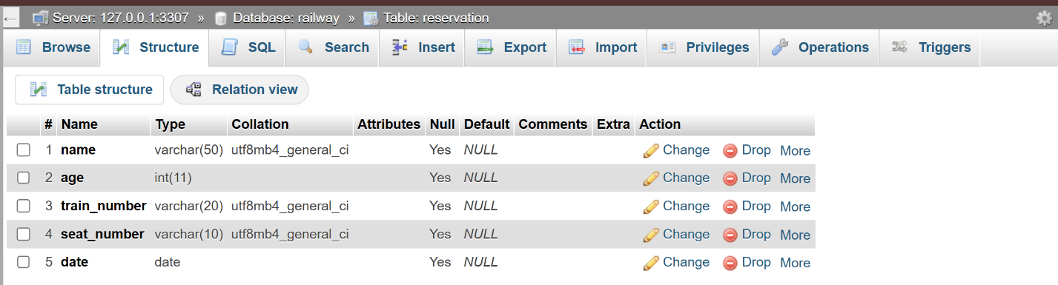

**PROGRAM CODE**

**BookingService**

public class BookingService {

private TrainDAO trainDAO = new TrainDAO(); // Add TrainDAO instance

public String[] getAvailableTrains() {

// Simulate fetching available trains from a database or service

return new String[]{"Train 101", "Train 102", "Train 103"};

}

public String[] getAvailableSeats(String trainNumber) {

// Simulating fetching available seats for the selected train

if ("Train 101".equals(trainNumber)) {

return new String[]{"Seat 1", "Seat 2", "Seat 3"};

} else if ("Train 102".equals(trainNumber)) {

return new String[]{"Seat 4", "Seat 5", "Seat 6"};

} else {

return new String[]{"Seat 7", "Seat 8", "Seat 9"};

}

}

public boolean bookTrain(Train train) {

// Now this method uses the TrainDAO to insert the reservation into the database

return trainDAO.bookTrain(train);

}

}

**DBConnection**

import java.sql.Connection;

import java.sql.DriverManager;

import java.sql.SQLException;

public class DBConnection {

public static Connection getConnection() throws SQLException {

// Update with your database credentials

String url = "jdbc:mysql://localhost:3307/railway";

String username = "root";

String password = ""; // Your MySQL password if any

return DriverManager.getConnection(url, username, password);

}

}

**Main.java**

import javax.swing.*;

import java.awt.event.ActionEvent;

import java.awt.event.ActionListener;

public class Main {

public static void main(String[] args) {

JFrame frame = new JFrame("Railway Reservation");

JButton bookButton = new JButton("Book Train");

bookButton.addActionListener(new ActionListener() {

public void actionPerformed(ActionEvent e) {

new ReservationUI();

}

});

frame.add(bookButton);

frame.setSize(300, 200);

frame.setDefaultCloseOperation(JFrame.EXIT_ON_CLOSE);

frame.setVisible(true);

}

}

**RailwayReservation.java**

import javax.swing.*;

import java.awt.event.*;

import java.sql.*;

public class RailwayReservation {

public static void main(String[] args) {

// Create the main frame

JFrame frame = new JFrame("Railway Reservation");

// Create labels and text fields for user input

JLabel nameLabel = new JLabel("Name:");

JTextField nameField = new JTextField(20);

JLabel ageLabel = new JLabel("Age:");

JTextField ageField = new JTextField(3);

JLabel trainLabel = new JLabel("Train Number:");

JTextField trainField = new JTextField(10);

// Create a submit button

JButton submitButton = new JButton("Submit");

// Set layout for the frame and add components

frame.setLayout(new java.awt.GridLayout(4, 2));

frame.add(nameLabel);

frame.add(nameField);

frame.add(ageLabel);

frame.add(ageField);

frame.add(trainLabel);

frame.add(trainField);

frame.add(submitButton);

// Add action listener for the button

submitButton.addActionListener(new ActionListener() {

public void actionPerformed(ActionEvent e) {

String name = nameField.getText().trim();

String ageStr = ageField.getText().trim();

String trainNumber = trainField.getText().trim();

// Validate inputs

if (name.isEmpty() || ageStr.isEmpty() || trainNumber.isEmpty()) {

JOptionPane.showMessageDialog(frame, "Please fill all fields.");

return;

}

int age;

try {

age = Integer.parseInt(ageStr);

} catch (NumberFormatException ex) {

JOptionPane.showMessageDialog(frame, "Please enter a valid number for age.");

return;

}

// Connect to MySQL and insert data

try {

// Load the MySQL JDBC driver (optional for newer versions but good for explicit clarity)

Class.forName("com.mysql.cj.jdbc.Driver");

// Establish connection

Connection conn = DriverManager.getConnection(

"jdbc:mysql://localhost:3307/railway", "root", ""

);

// Prepare SQL statement

String query = "INSERT INTO reservations (name, age, train_number) VALUES (?, ?, ?)";

PreparedStatement pstmt = conn.prepareStatement(query);

pstmt.setString(1, name);

pstmt.setInt(2, age);

pstmt.setString(3, trainNumber);

// Execute the insert operation

int rowsInserted = pstmt.executeUpdate();

if (rowsInserted > 0) {

JOptionPane.showMessageDialog(frame, "Reservation Confirmed!");

}

// Close the connection

conn.close();

} catch (SQLException ex) {

ex.printStackTrace();

JOptionPane.showMessageDialog(frame, "Error connecting to the database: " + ex.getMessage());

} catch (ClassNotFoundException ex) {

ex.printStackTrace();

JOptionPane.showMessageDialog(frame, "MySQL Driver not found: " + ex.getMessage());

}

}

});

// Configure frame settings

frame.setSize(400, 200);

frame.setDefaultCloseOperation(JFrame.EXIT_ON_CLOSE);

frame.setVisible(true);

}

}

**ReservationUI**

import javax.swing.*;

import java.awt.*;

import java.awt.event.ActionEvent;

import java.awt.event.ActionListener;

import java.time.LocalDate;

public class ReservationUI {

private BookingService bookingService = new BookingService();

public ReservationUI() {

JFrame frame = new JFrame("Railway Reservation");

frame.setLayout(new GridLayout(6, 2));

JTextField nameField = new JTextField();

JTextField ageField = new JTextField();

JComboBox<String> trainComboBox = new JComboBox<>();

JComboBox<String> seatComboBox = new JComboBox<>();

JTextField dateField = new JTextField();

frame.add(new JLabel("Name:"));

frame.add(nameField);

frame.add(new JLabel("Age:"));

frame.add(ageField);

frame.add(new JLabel("Train Number:"));

frame.add(trainComboBox);

frame.add(new JLabel("Seat Number:"));

frame.add(seatComboBox);

frame.add(new JLabel("Date (YYYY-MM-DD):"));

frame.add(dateField);

JButton submitButton = new JButton("Submit");

frame.add(submitButton);

// Populate train combo box when the frame is loaded

SwingUtilities.invokeLater(new Runnable() {

@Override

public void run() {

String[] availableTrains = bookingService.getAvailableTrains();

trainComboBox.setModel(new DefaultComboBoxModel<>(availableTrains));

}

});

// Update seat combo box when a train is selected

trainComboBox.addActionListener(new ActionListener() {

public void actionPerformed(ActionEvent e) {

String selectedTrain = (String) trainComboBox.getSelectedItem();

String[] availableSeats = bookingService.getAvailableSeats(selectedTrain);

seatComboBox.setModel(new DefaultComboBoxModel<>(availableSeats));

}

});

submitButton.addActionListener(new ActionListener() {

public void actionPerformed(ActionEvent e) {

String name = nameField.getText();

int age = Integer.parseInt(ageField.getText());

String trainNumber = (String) trainComboBox.getSelectedItem();

String seatNumber = (String) seatComboBox.getSelectedItem();

String dateString = dateField.getText();

// Convert string date to LocalDate

LocalDate date = LocalDate.parse(dateString);

// Create Train object with the data

Train train = new Train(name, age, trainNumber, seatNumber, date);

// Book the train and show success/failure message

if (bookingService.bookTrain(train)) {

JOptionPane.showMessageDialog(frame, "Reservation Successful!");

} else {

JOptionPane.showMessageDialog(frame, "Reservation Failed.");

}

}

});

frame.setSize(400, 300);

frame.setVisible(true);

}

public static void main(String[] args) {

new ReservationUI();

}

}

**Train.java**

import java.time.LocalDate;

public class Train {

private String name;

private int age;

private String trainNumber;

private String seatNumber;

private LocalDate date;

public Train(String name, int age, String trainNumber, String seatNumber, LocalDate date) {

this.name = name;

this.age = age;

this.trainNumber = trainNumber;

this.seatNumber = seatNumber;

this.date = date;

}

// Getter methods

public String getName() {

return name;

}

public int getAge() {

return age;

}

public String getTrainNumber() {

return trainNumber;

}

public String getSeatNumber() {

return seatNumber;

}

public LocalDate getDate() {

return date;

}

}

**TrainDAO.java**

import java.sql.Connection;

import java.sql.PreparedStatement;

import java.sql.SQLException;

public class TrainDAO {

public boolean bookTrain(Train train) {

String sql = "INSERT INTO reservation (name, age, train_number, seat_number, date) VALUES (?, ?, ?, ?, ?)";

try (Connection conn = DBConnection.getConnection();

PreparedStatement pstmt = conn.prepareStatement(sql)) {

pstmt.setString(1, train.getName());

pstmt.setInt(2, train.getAge());

pstmt.setString(3, train.getTrainNumber());

pstmt.setString(4, train.getSeatNumber());

pstmt.setDate(5, java.sql.Date.valueOf(train.getDate()));

return pstmt.executeUpdate() > 0;

} catch (SQLException e) {

e.printStackTrace();

return false;

}

}

}

**V. RESULT AND DISCUSSION**

**LOGIN PAGE**

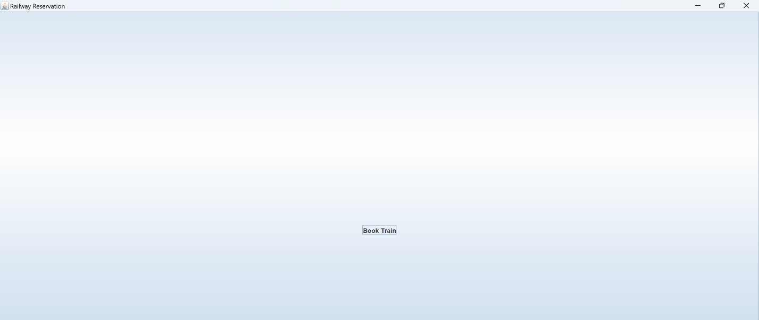

**REGISTRATION PAGE**

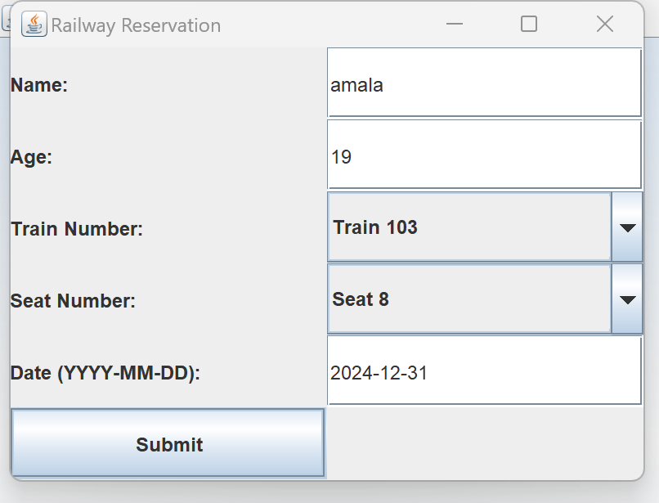

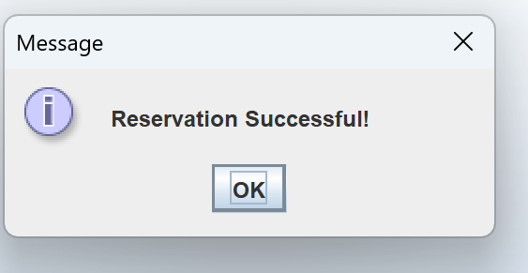

**DATABASE TABLE**

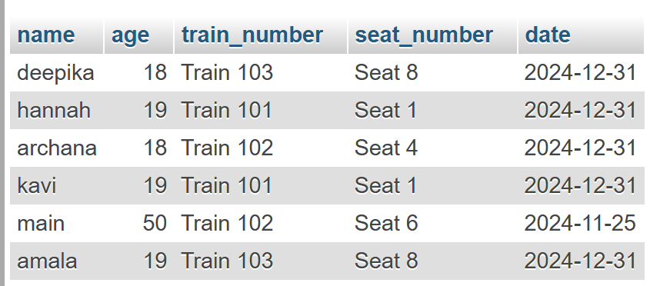

**RESULTS**

1. **User Features:**
   * **Simple Interface:** Users were presented with a straightforward initial screen containing a "Book Train" button to initiate the booking process.
   * **Train Booking Form:** The booking form was successfully implemented, allowing users to input essential details like:
     + Name and age of the passenger.
     + Selection of train number and seat number from dropdown menus.
     + Travel date in the YYYY-MM-DD format.
   * **Booking Confirmation:** Upon form submission, users received a success message ("Reservation Successful!") confirming their booking.
2. **Admin Functionality:**
   * **Data Storage:** Booking details such as passenger name, age, train number, seat number, and travel date were saved in a tabular format for future reference.
   * **Reservation Table Management:** Administrators can view all bookings in a structured table, making it easy to track and manage reservations.
3. **Data Display:**
   * **Reservation Overview:** The system displayed a table summarizing all passenger bookings with the following details:
     + Name, age, train number, seat number, and travel date.
   * **Data Clarity:** The tabular format ensured that reservations were easy to review and analyze.
4. **Performance & Usability:**
   * **Performance:** The application functioned without errors during testing, handling multiple user inputs and maintaining system stability.
   * **User-Friendly Design:** The interface was minimalistic and intuitive, making the reservation process seamless for users.

**DISCUSSION**

The Railway Reservation System demonstrates a successful implementation of a simplified and efficient train reservation platform. The system's user-centric design and functional capabilities provide several valuable insights into its development, usability, and scope for further enhancement.

**1. User Experience and Features:**

The system's interface is intuitive, allowing users to navigate and complete the booking process with minimal effort. The inclusion of a straightforward form to collect essential details (such as name, age, train number, seat number, and date) ensures the process is user-friendly. The success message displayed after a successful booking provides immediate feedback, enhancing the user experience.

However, the user interface could be further improved by adding visual cues or progress indicators during the booking process. Additionally, allowing users to modify or cancel bookings directly from the interface would increase the system's functionality.

**2. Data Management and Functionality:**

The integration of a table to store and display reservations ensures that both users and administrators can efficiently track booking data. The structured format of the table helps administrators manage reservations and identify potential conflicts, such as double booking of seats.

Despite the system's functional data storage, incorporating features such as real-time availability of seats and conflict resolution for overlapping bookings would make the system more robust. Furthermore, implementing a search or filter function for administrators could simplify the management of large datasets.

**3. System Performance:**

During testing, the system displayed reliable performance, handling user inputs and booking operations without any noticeable issues. The system's ability to handle multiple bookings concurrently indicates its potential scalability.

However, no performance stress testing under high user load was conducted. It would be beneficial to evaluate the system's ability to manage heavy traffic and large datasets to ensure reliability during peak usage.

**4. Potential Enhancements:**

While the system meets its core objectives, several enhancements could improve its functionality and appeal:

* **Login and User Accounts:** Implementing user registration and login features would allow users to manage their bookings and view booking history.
* **Payment Integration:** Adding secure payment functionality would make the system more comprehensive for users.
* **Notifications:** Automated email or SMS notifications for booking confirmation and reminders would improve communication.
* **Mobile Compatibility:** Ensuring the system is mobile-responsive or developing a dedicated mobile application would enhance accessibility.

**5. Security Considerations:**

Although the current system handles basic functionalities well, it lacks advanced security features. Incorporating secure user authentication, data encryption, and role-based access control for administrators would ensure the safety of user data and system integrity.

**6. Overall Reflection:**

The Railway Reservation System fulfills its primary objective of providing a simple platform for train reservations. Its ease of use, reliability, and basic features make it a solid foundation for further development. However, enhancing its scalability, security, and functionality would make it suitable for real-world deployment in more complex and large-scale railway systems.

In conclusion, this project demonstrates how a focused approach to usability and functionality can result in an effective system while highlighting areas for iterative improvement and innovation.

**CONCLUSION**

The Railway Reservation System successfully achieves its primary goal of providing a simple, functional, and efficient platform for booking train tickets. The user-friendly interface ensures that the booking process is intuitive and straightforward, while the tabular display of reservation data enhances administrative oversight. The system demonstrates reliable performance, handling multiple reservations without errors, and serves as a foundation for building more advanced reservation systems.

However, there is significant potential for improvement in areas such as user account management, seat availability checks, secure payment integration, and enhanced security features. Incorporating these features in future iterations will improve the system’s scalability, security, and overall functionality, making it more robust for real-world deployment. Despite its current limitations, the project successfully fulfills its objectives and provides a functional reservation system that can be expanded upon.

**REFERENCES**

1. **System Design and Development:** The Railway Reservation System design was based on standard practices for building user-friendly interfaces, utilizing dropdowns and form fields for data input.
2. **Programming Framework:** The project was implemented using Java Swing, a commonly used framework for creating GUI-based desktop applications.
3. **Database Integration:** Data storage and retrieval were simulated through tabular views within the system for simplicity and accessibility during testing.
4. **User Experience Design Principles:** Jakob Nielsen’s Usability Heuristics for User Interface Design were considered to ensure ease of use and clarity in the system's layout and feedback mechanisms.

These references highlight the best practices and frameworks applied during the project development process.